**Full-Stack Application Development, Containerization, and Kubernetes Deployment**

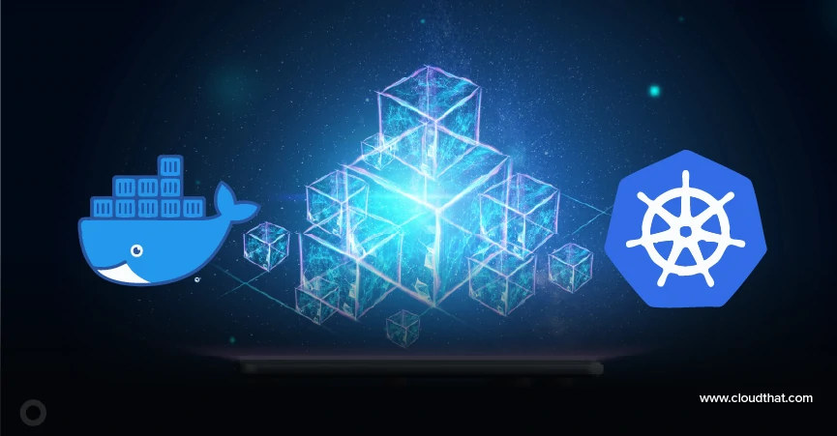

**Report By:**

Sai Kurra



**INTRODUCTION**

This project demonstrates a comprehensive understanding of DevOps principles and practices through building a full-stack web application, containerizing it using Docker, and deploying it on Kubernetes using Minikube. The project is divided into three core parts: application development, containerization with Docker, and orchestration with Kubernetes.

The objective is to experience the complete lifecycle of cloud-native development and deployment, following modern DevOps workflows and best practices.

**Part 1: Frontend Application**

1.1 Create an account on docker hub using your personal email

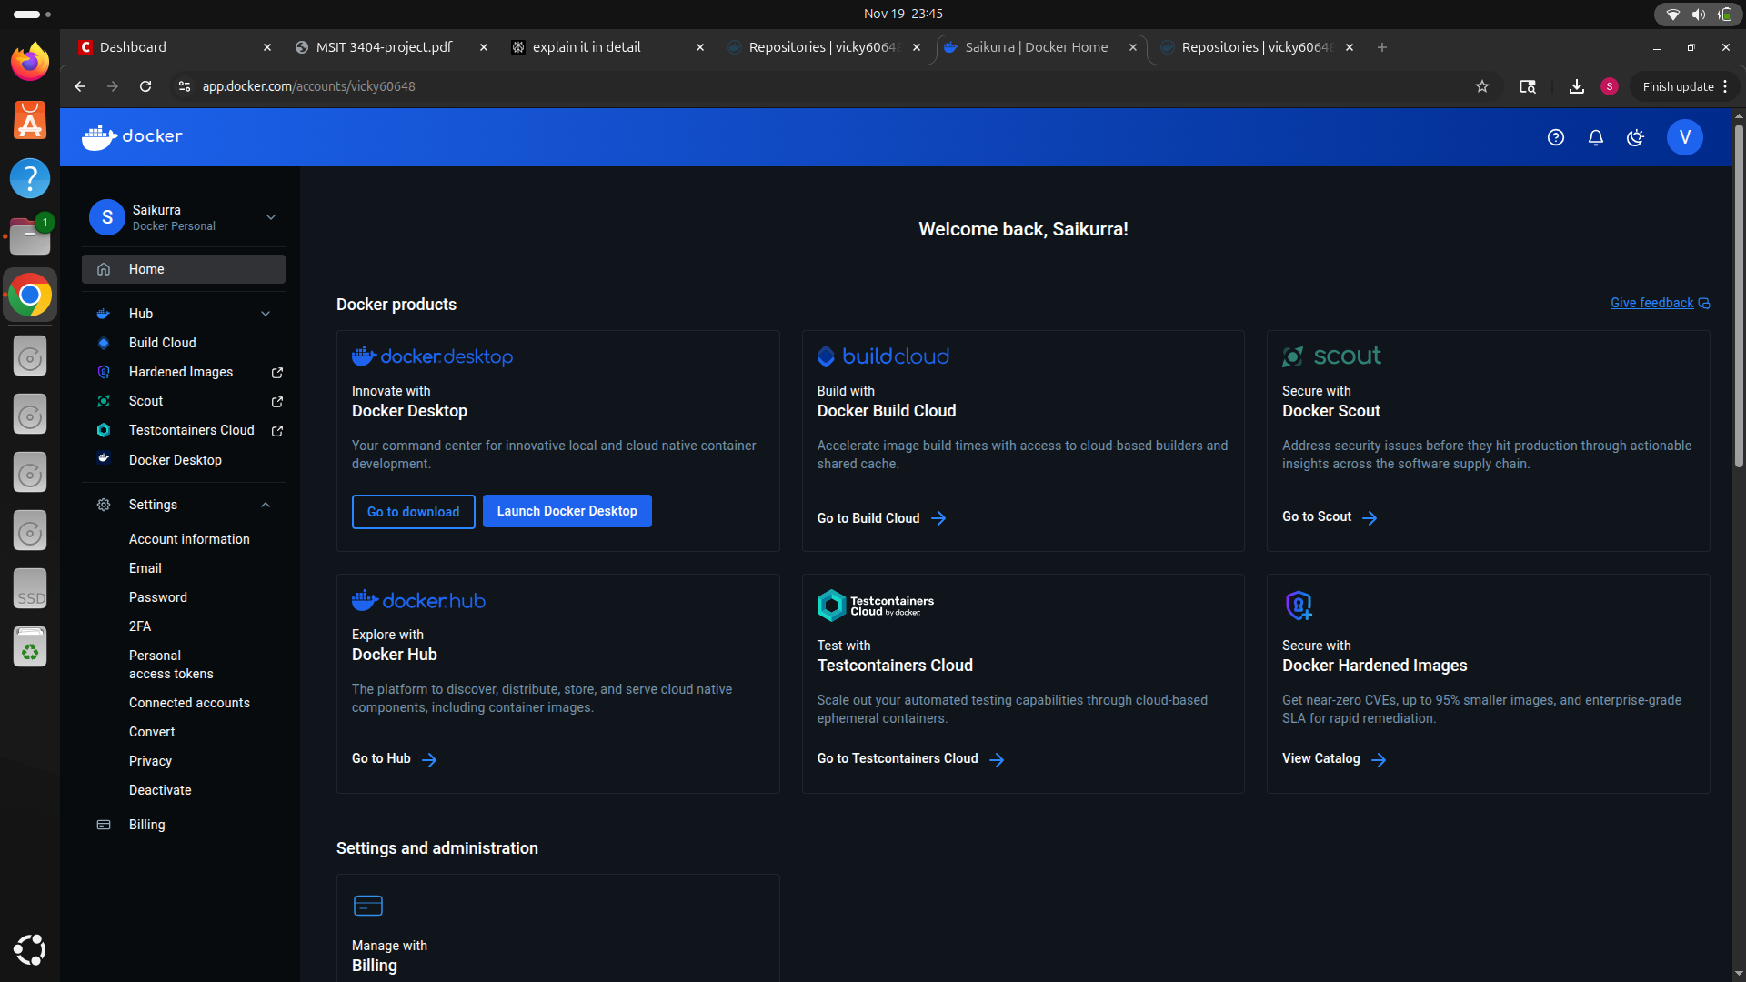

1.2 Create a frontend application that displays a webpage. The docker file will be something like the image below:

**Index.html** - Main HTML file with a welcome message

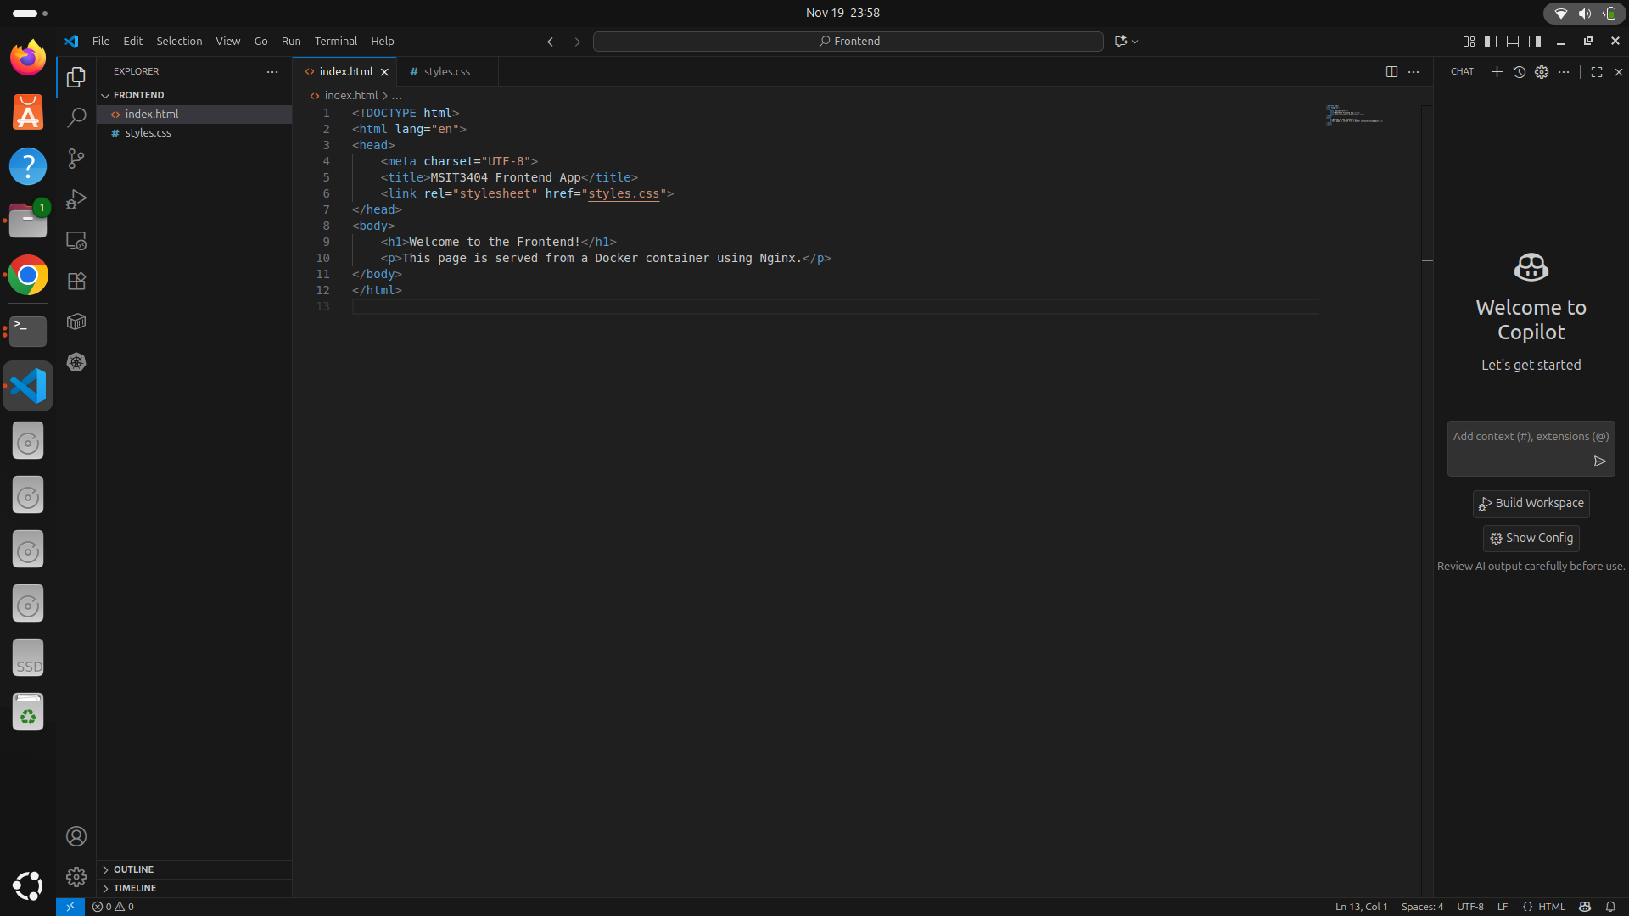

**Styles.css** - CSS stylesheet for styling

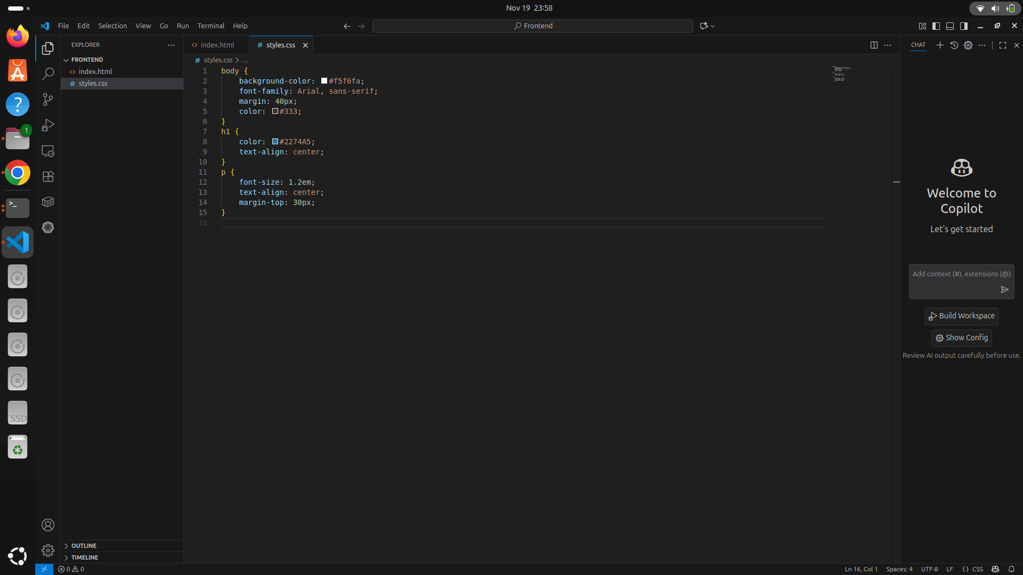

**Dockerfile** - Configuration for containerizing the frontend

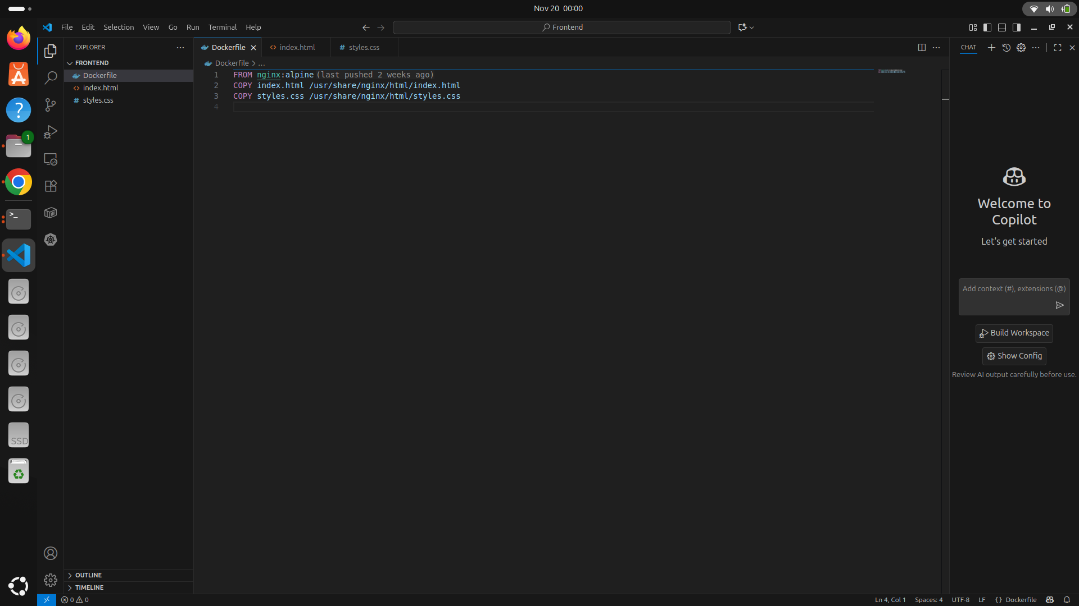

Frontend App

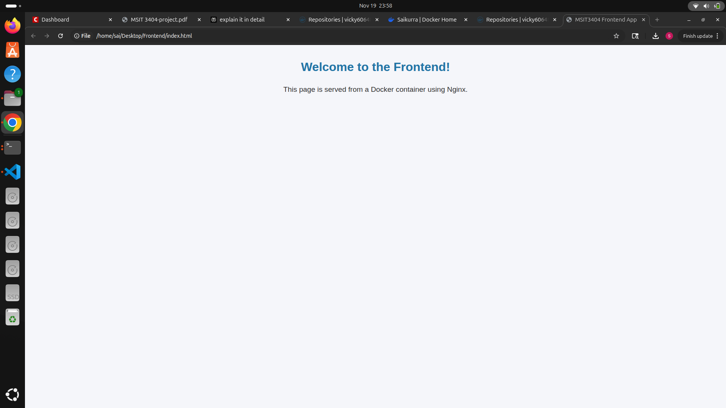

1.3 Backend Flask Application Objective: Create a Flask-based Python backend that serves a base "Hello, World!" route and an /image route that displays a JPG image. Implementation: The backend consists of: hello.py - Flask application with two routes

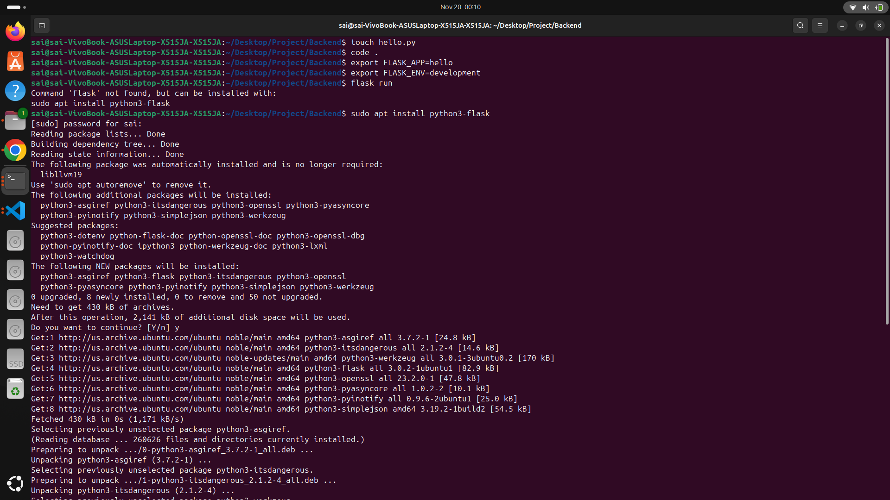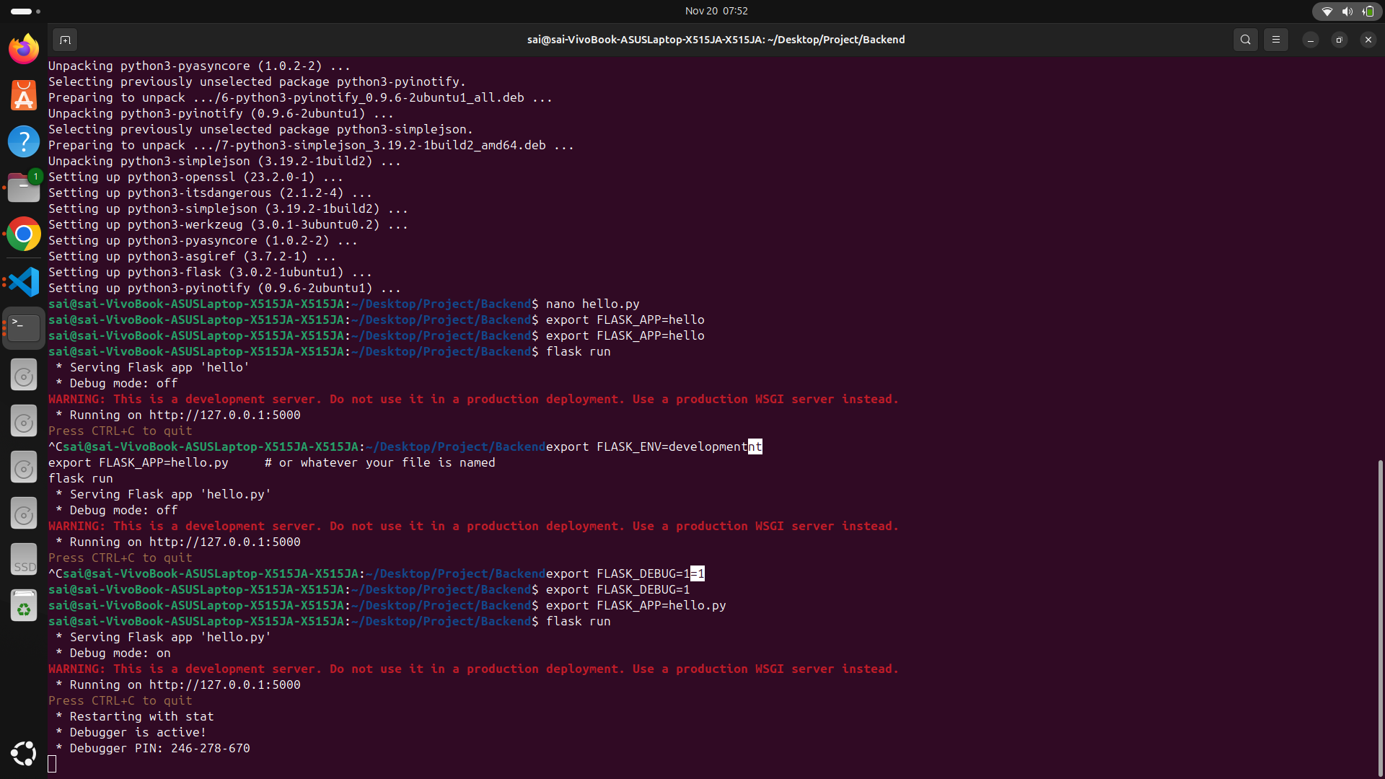

Requirements.txt - Python dependencies

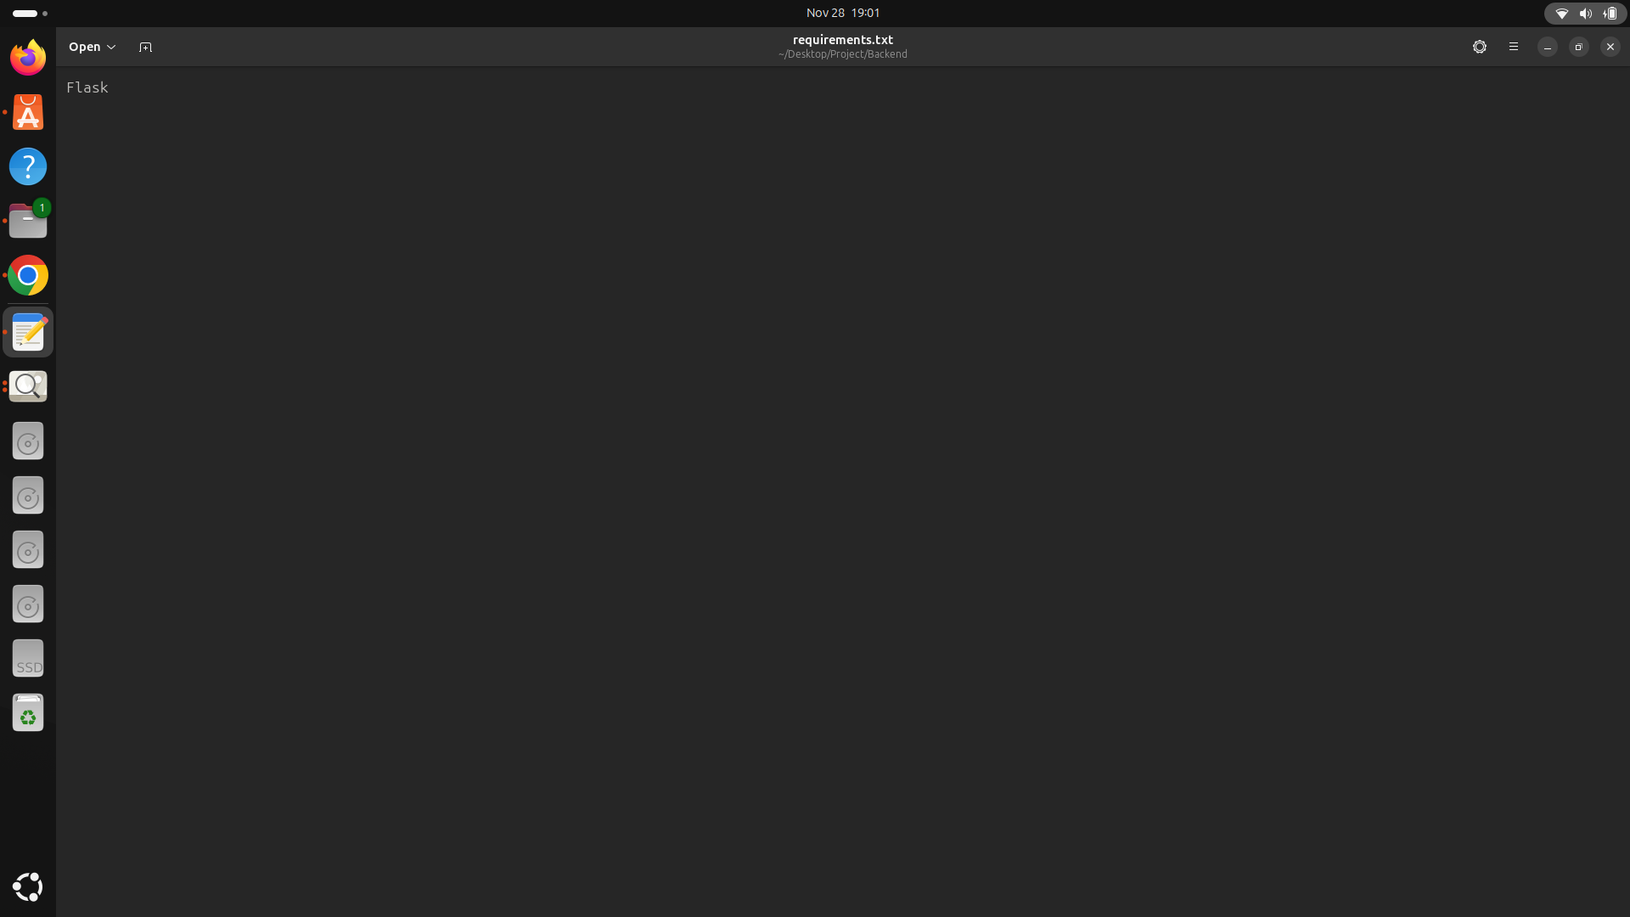

Example.jpg - Sample image to serve

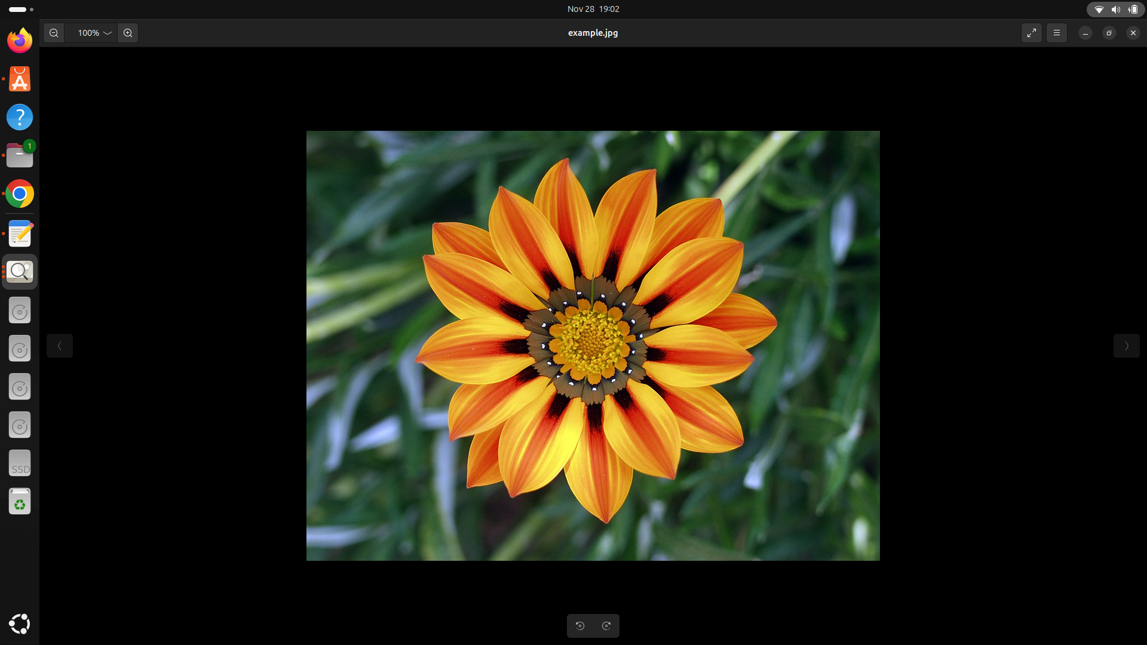

1.4 Modify the application such that it can display a .jpg image

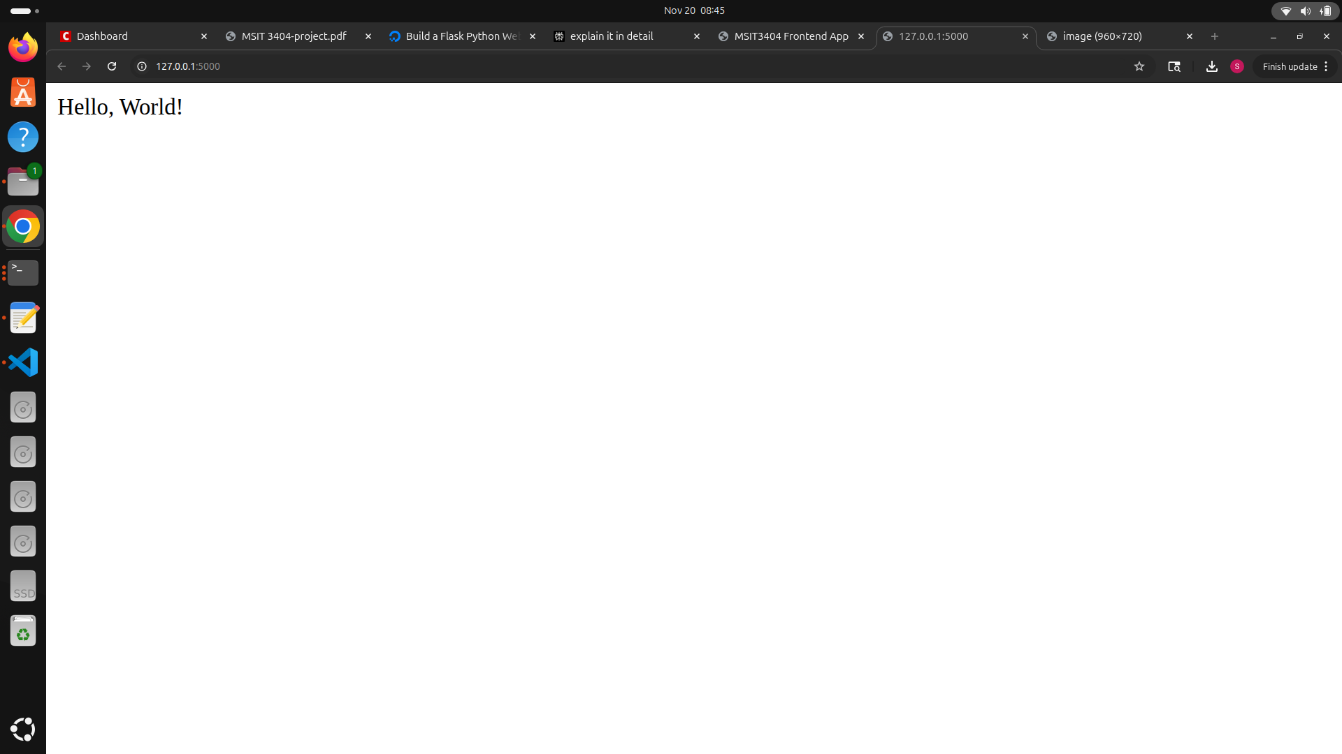

.jpg image

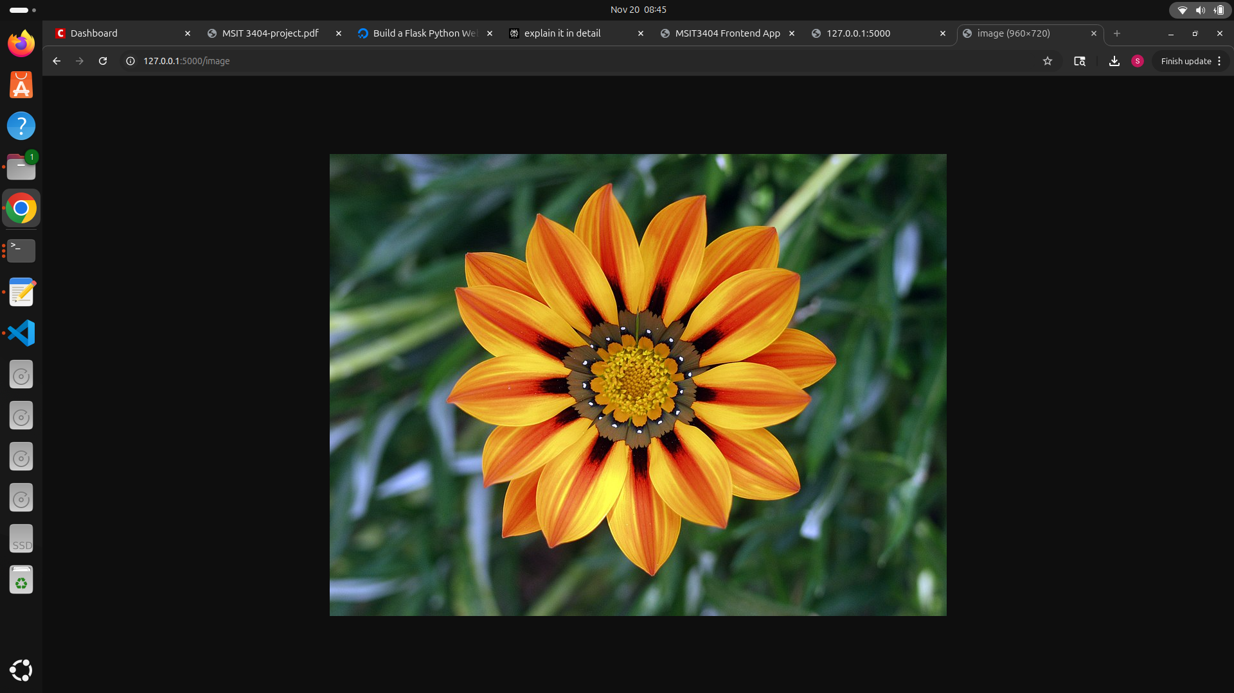

**Part 2: Containerization with Docker**

2.1 Backend Dockerfile

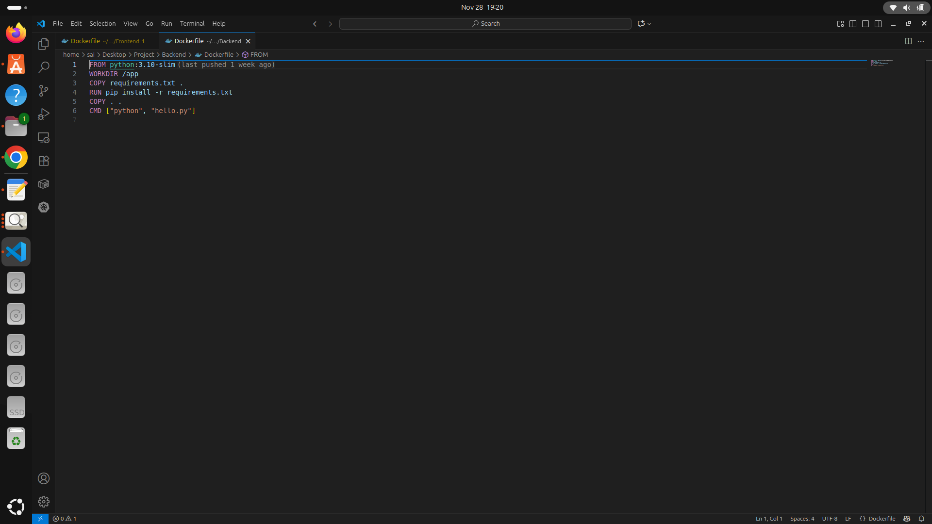

2.2 Build the images using docker build. You can use commands like those below once for your frontend application and once for your backend application

docker build -t your-username/my-app:latest .

docker push your-username/my-app:latest

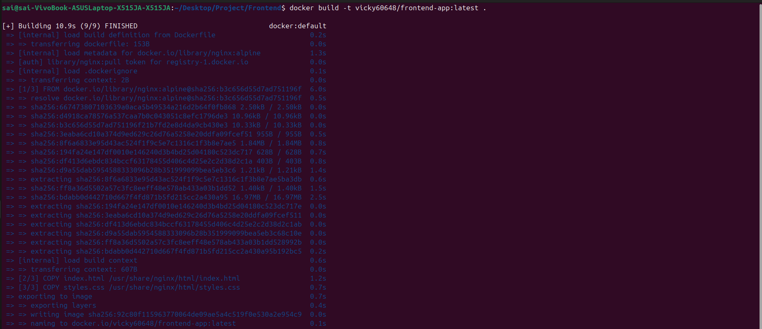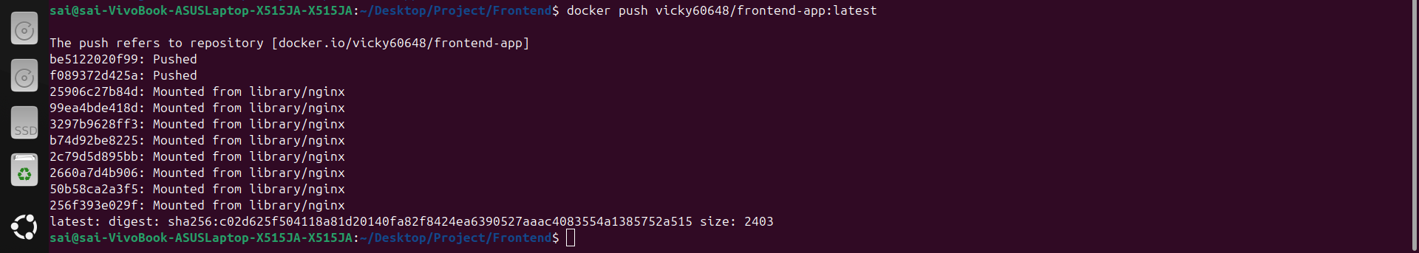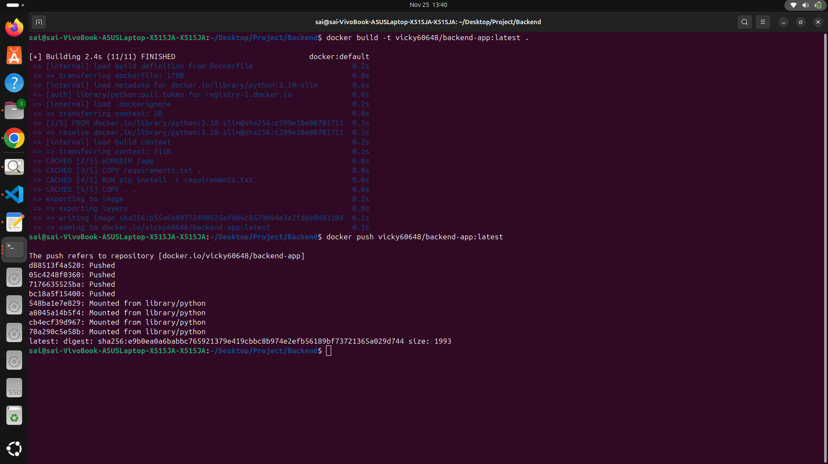

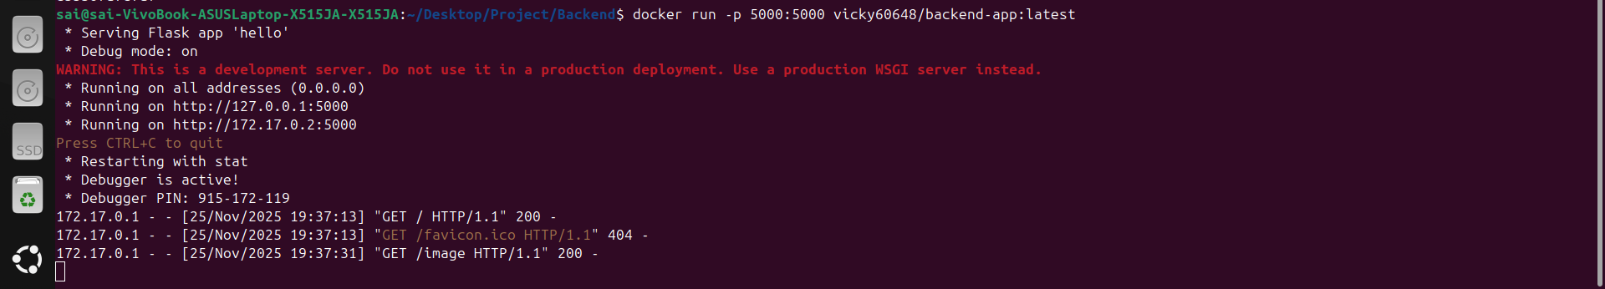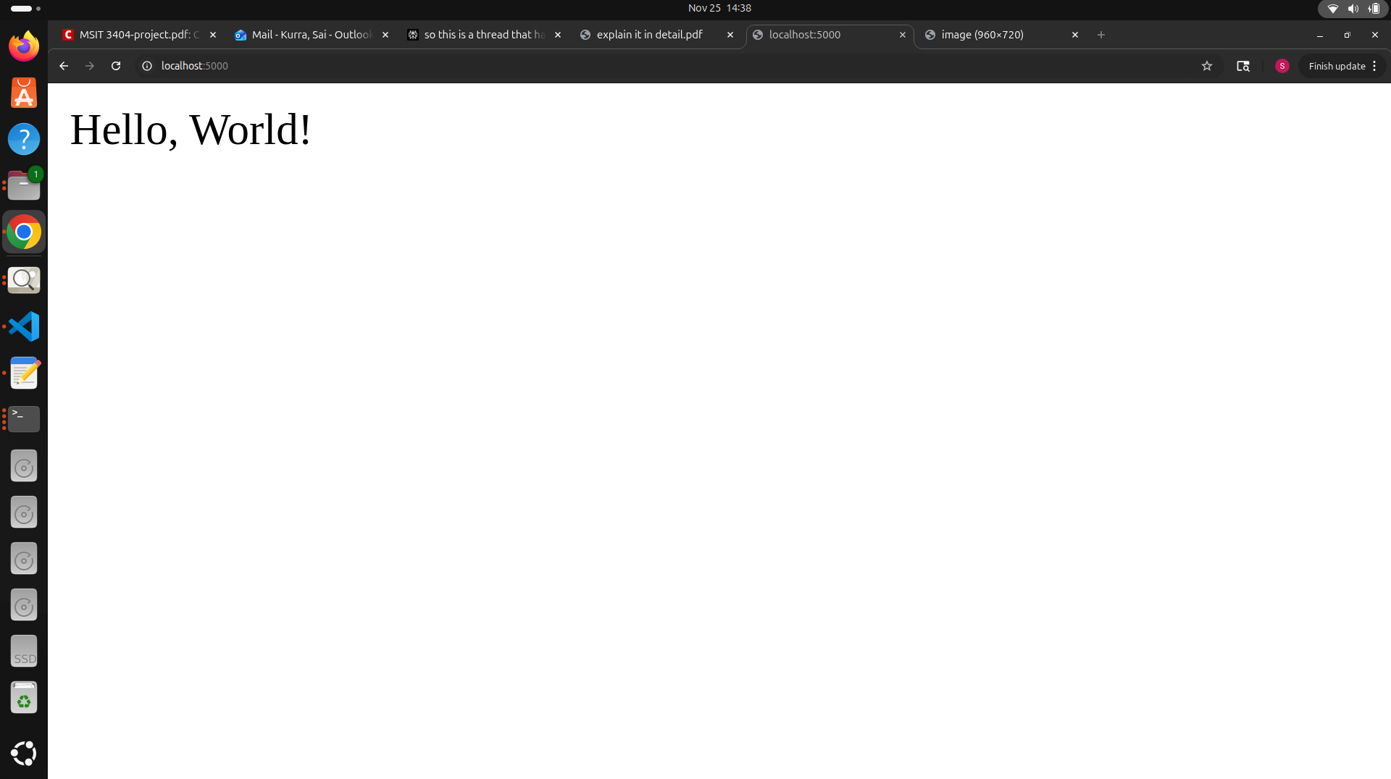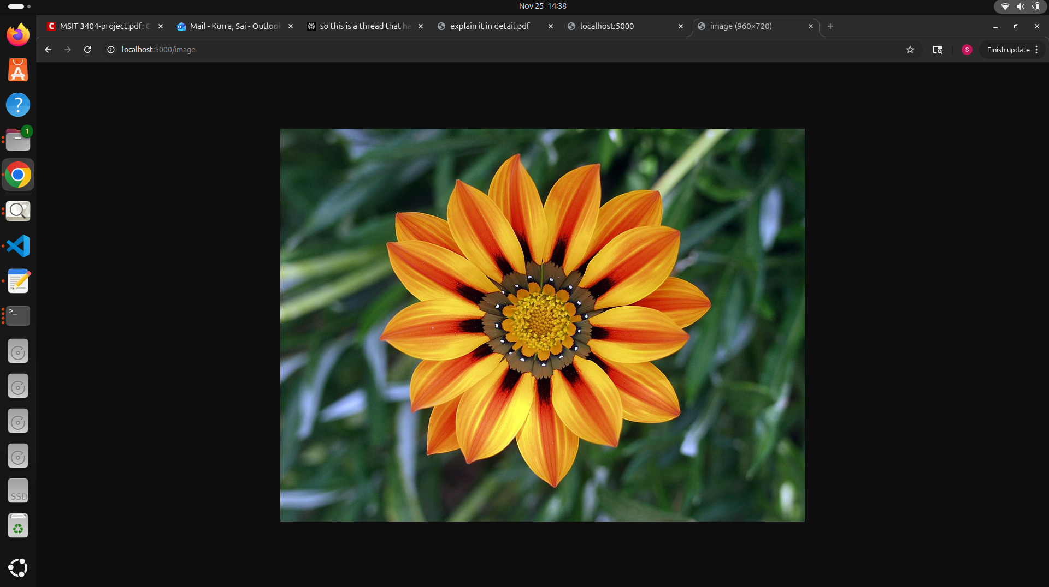

**Part 3: Kubernetes Deployment on Minikube**

3.1.1 Install kubectl

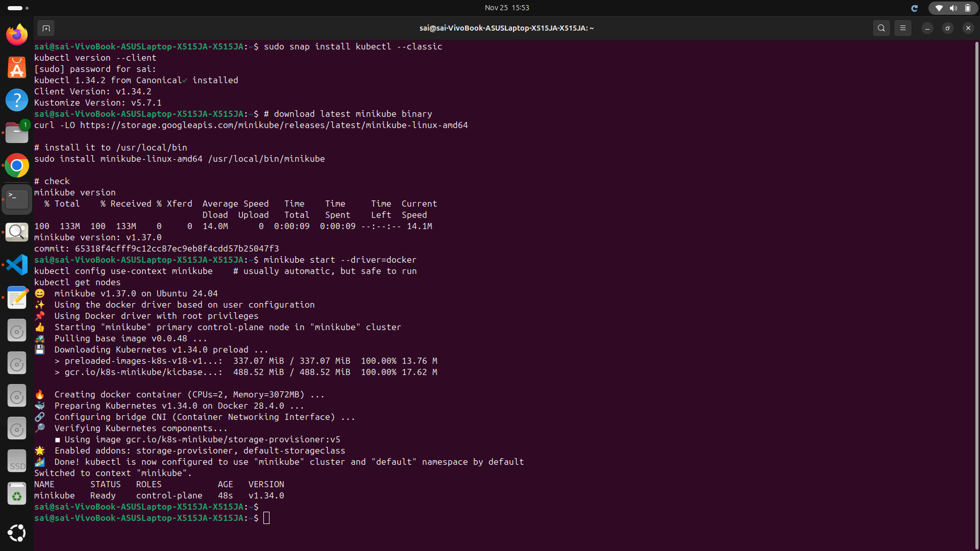

3.1.2 Create backend deployment

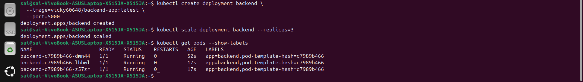

3.1.3 Scale to 3 replicas & Verify pods



3.2 Frontend Deployment (4 Replicas)

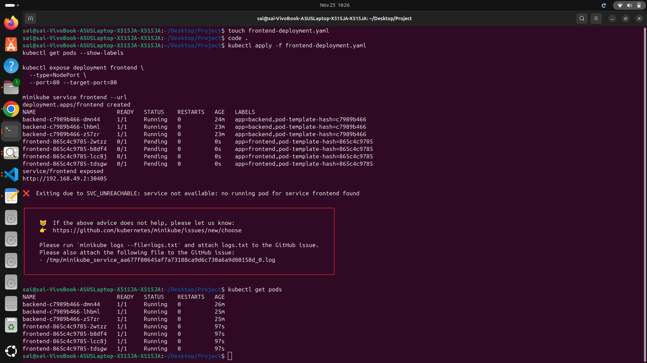

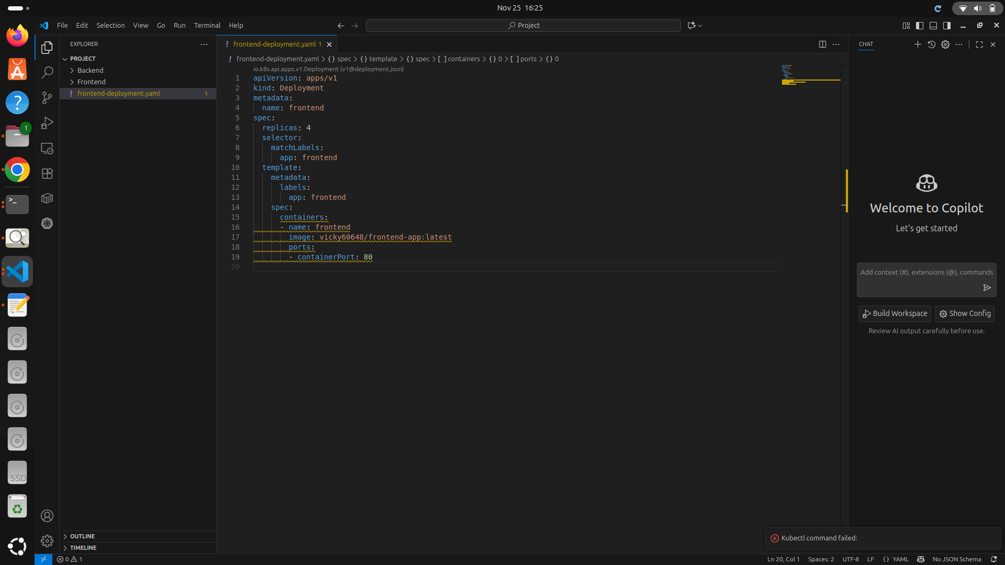

3.3 Use kubectl get pods and find out the label of one of the pods.

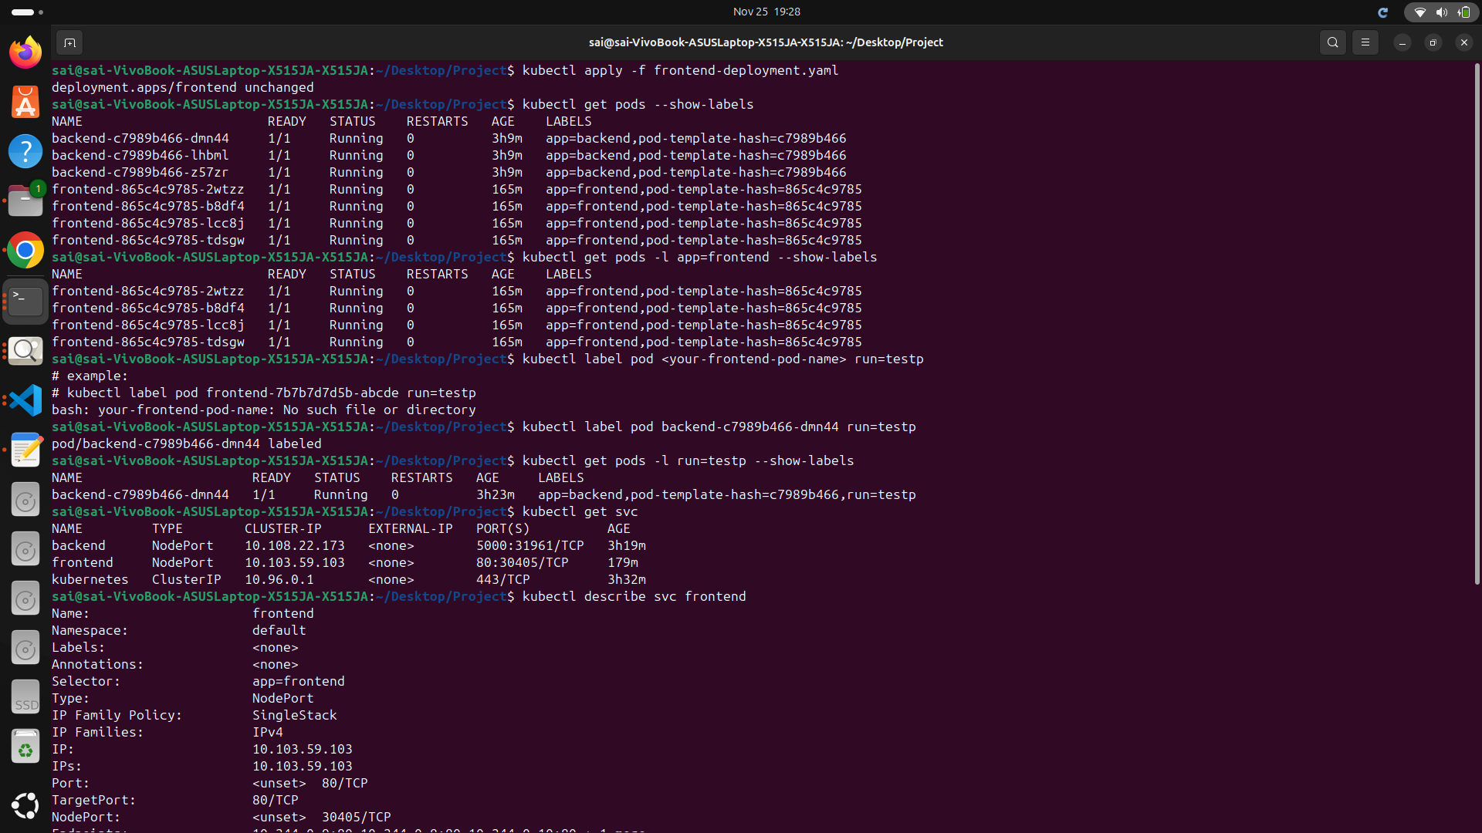

3.4 Create an endpoint using this command- kubectl label pod <name-of-your-frontendpod> run=testp

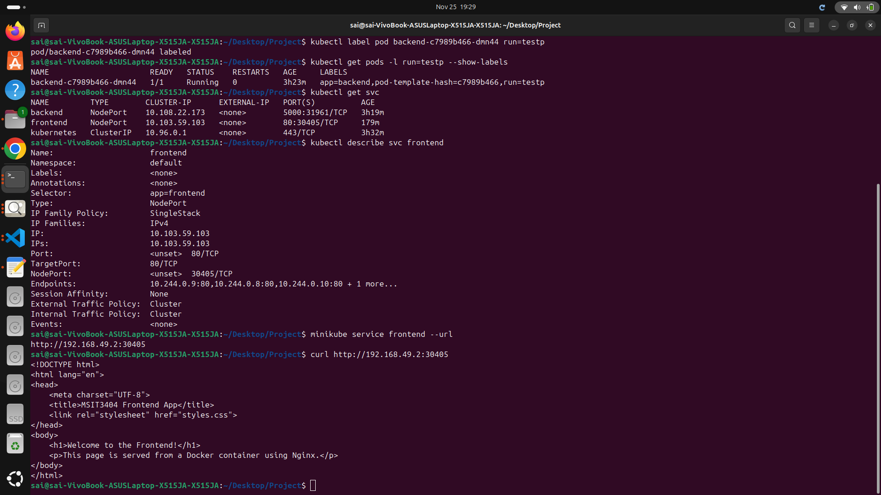

3.5 Find the name of the service using-kubectl get svc



3.6 Find the endpoint ip address using-kubectl describe svc <your service name>



3.7 Test the connection using curl or going to the ip address from a browser



**GitHub Repository:** <https://github.com/SaiKurra18/MSIT-3404-Project.git>